***Shell Strength Protocol***

**Supplies**

* Caliper to measure shell thickness <https://www.amazon.com/gp/product/B00BC3KIO2/ref=oh_aui_detailpage_o08_s00?ie=UTF8&psc=1>
* Caliper to for other measurements <https://www.amazon.com/iGaging-8-Digital-Outside-Calipers/dp/B002PU77Q8/ref=pd_bxgy_469_img_2?_encoding=UTF8&psc=1&refRID=Z70NGQ6EB7NSE6DMCGYR>
* Instron with proper equiptment
* Table cloths or tarps to cover machine parts
* Safety goggles
* Paint marker
* FSW and bucket
* Scale

**Shell preparation:**

Shells were brushed clean thoroughly after dissection (n=15 per treatment). Before shell strength tests, shells were soaked for 24-48 hours in fresh seawater. Shells were measured, weighed, and evaluated for boring mussels (Lithophaga plumula), cracks, or other abnormalities. Shells were marked at 4 equally spaced points across the length of the shell, using a paint marker. 3 points were marked along the main length of the shell, and one point at the umbo.

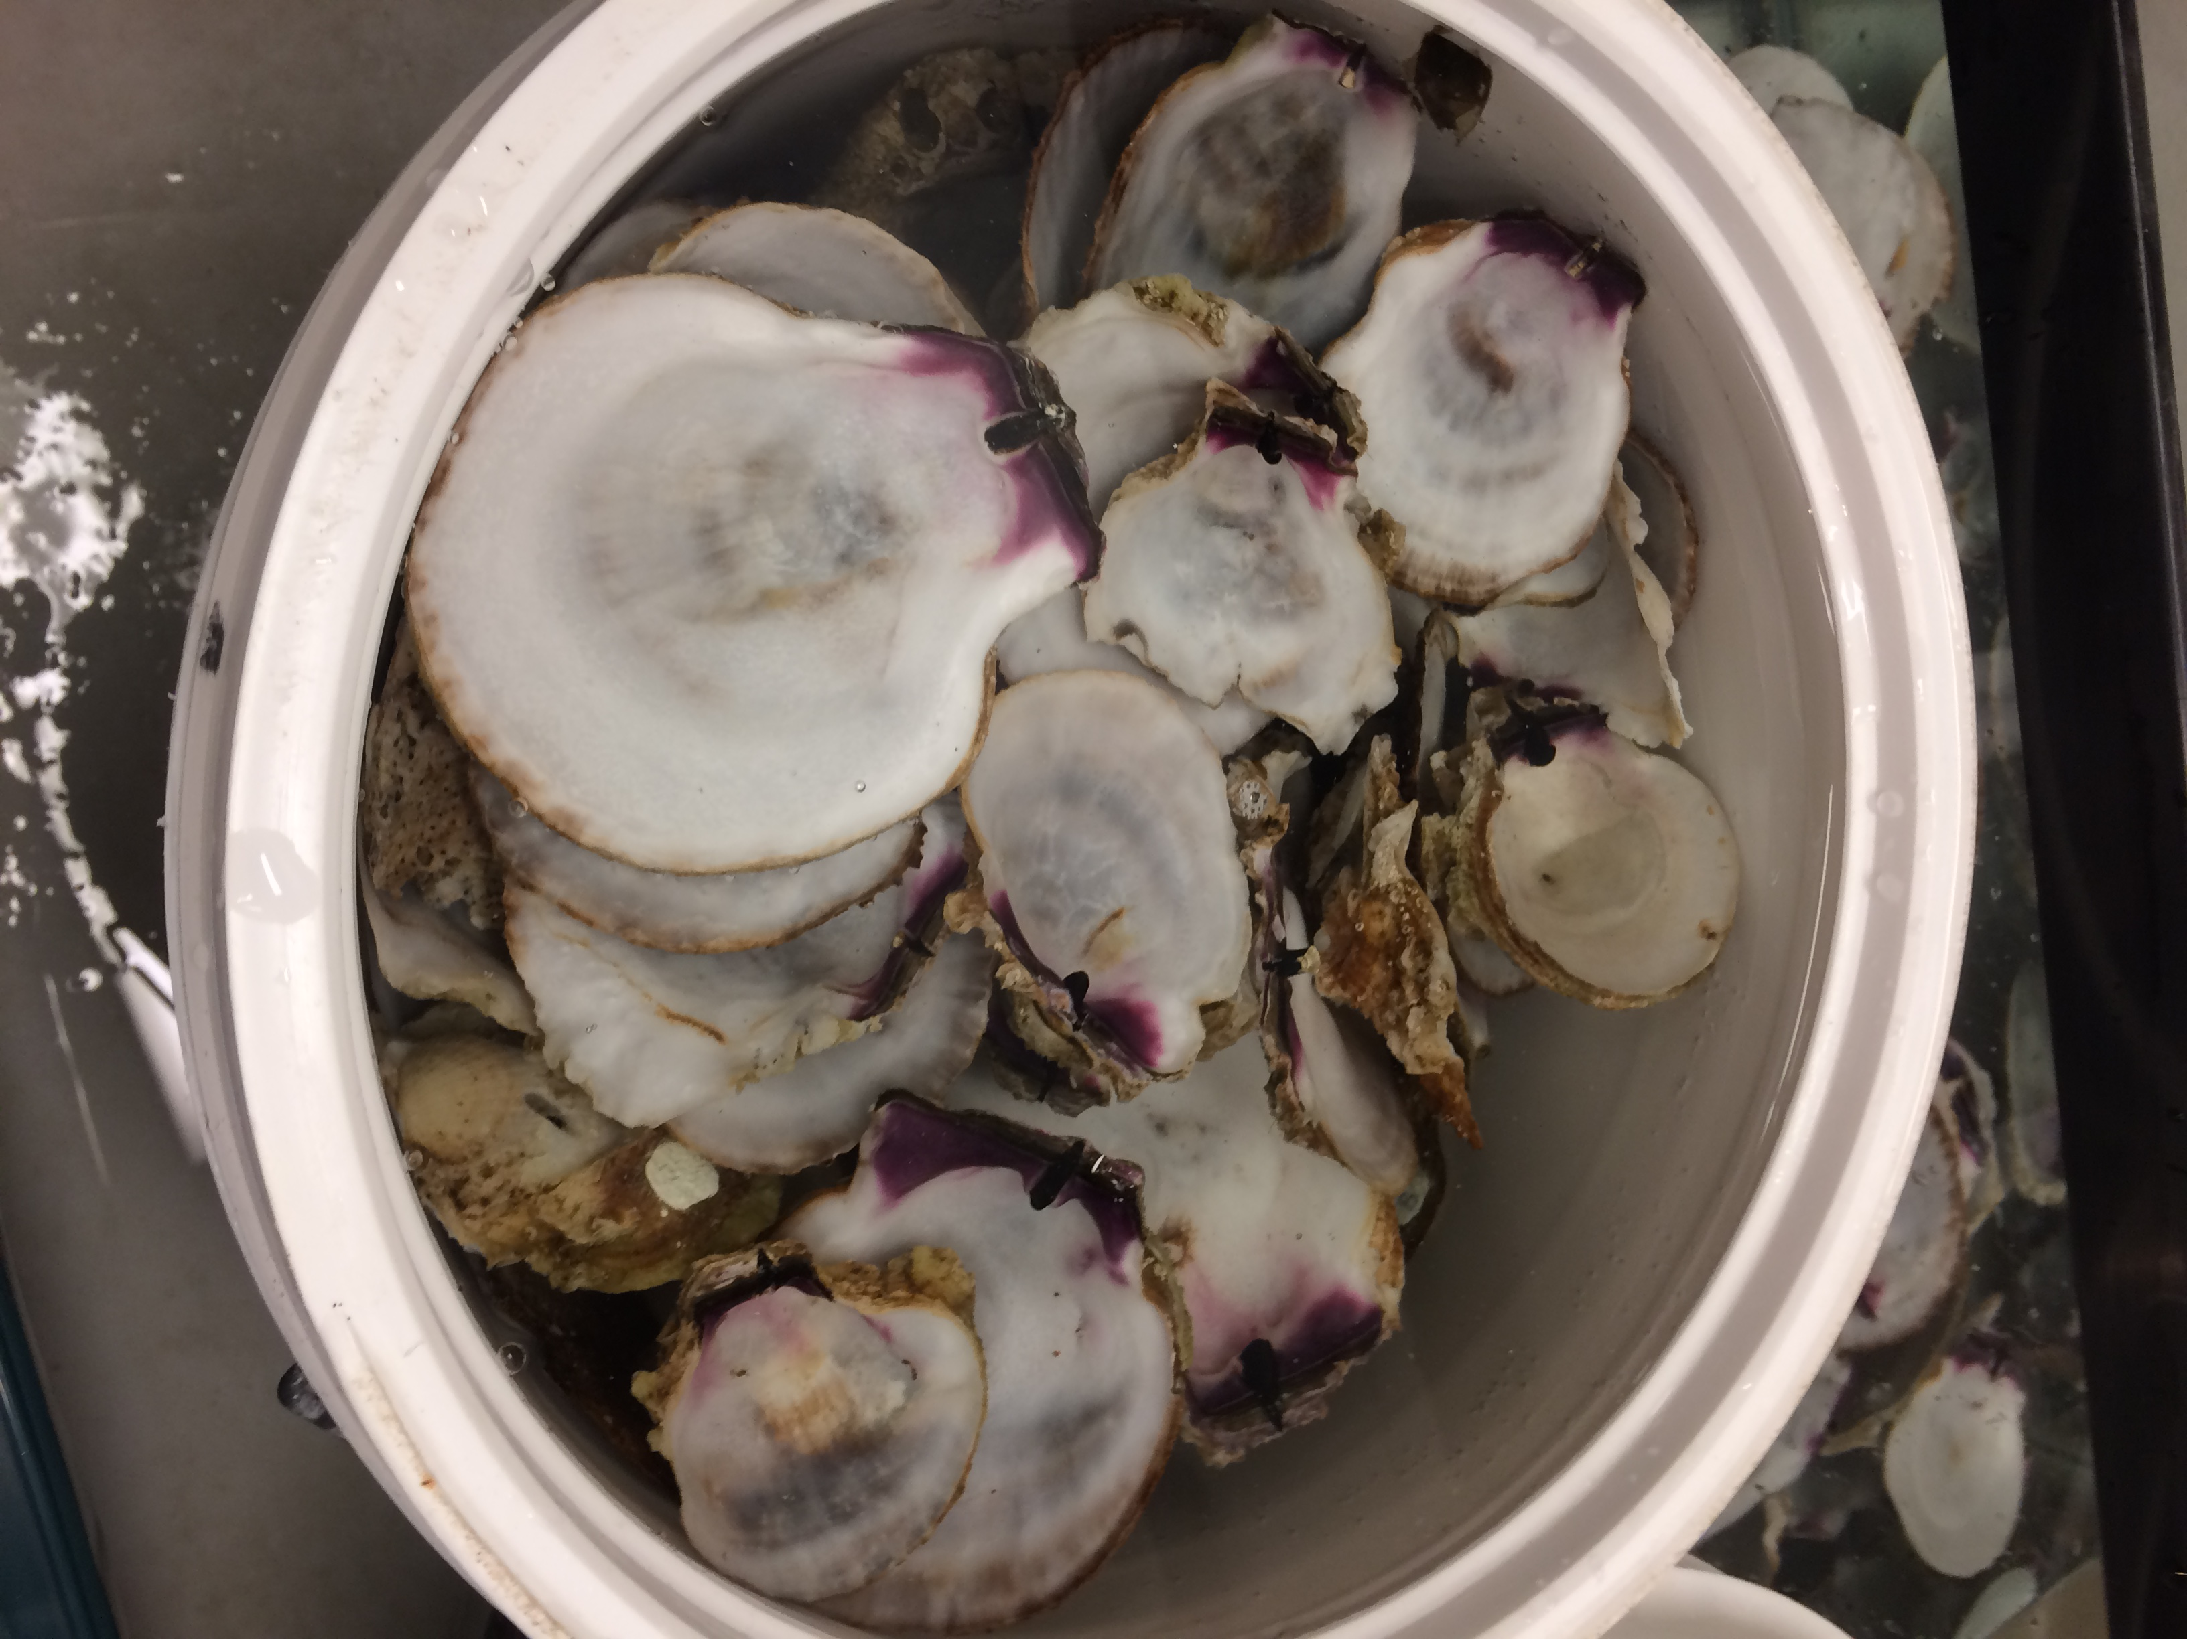

**Instron preparation:**

The Universal Testing machine (Instron, model 5585H) was fitted with a 3.9 mm cylindrical blunt head and a 4.76mm hole within a plate beneath (Wilke and Bishop 2013). The shells were removed from the saltwater and immediately placed onto the stage, inner side facing upward on a marked point. The shell were held perpendicular to the Instron plate by an adjustable wire loop. A program was set up on Bluehill Software (v.2) (Illinois Tool Works Inc, IL, USA). to measure maximum load (N) and the measurement to which that force was reached (mm). 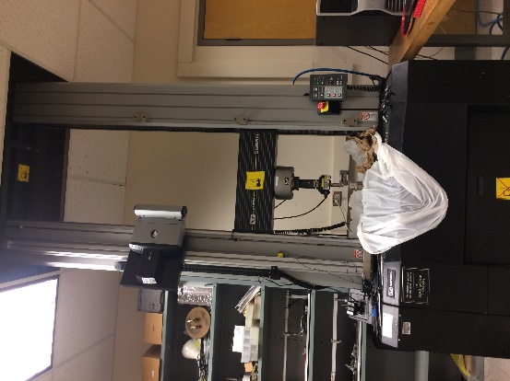

**Crushing method:**

The crushing tip was slowly lowered onto the shell until 20 N was reached, then the measurements were cleared. The Bluehill test was initiated, crushing the shell at a crosshead speed of 5 mm/s, and programmed to stop at 80% drop in maximum force. A hole was fully punctured in the shell.

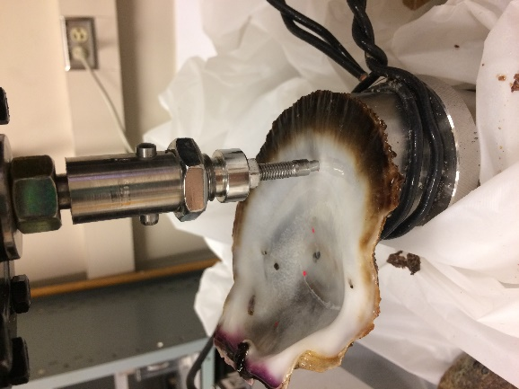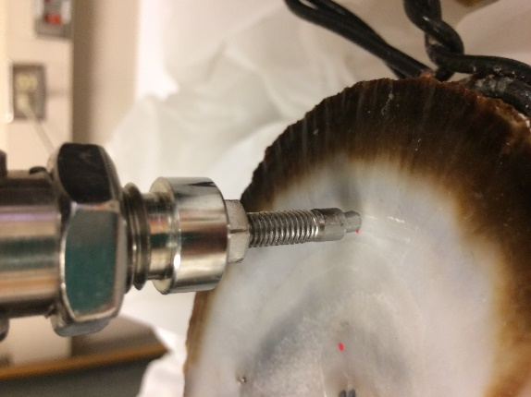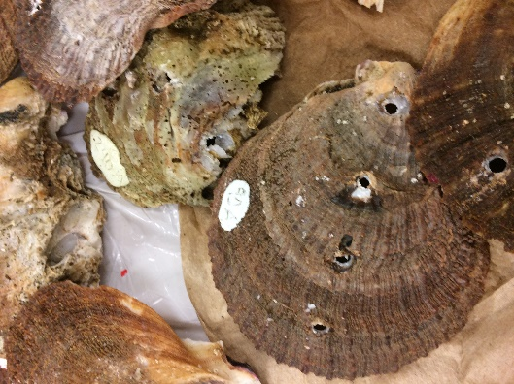

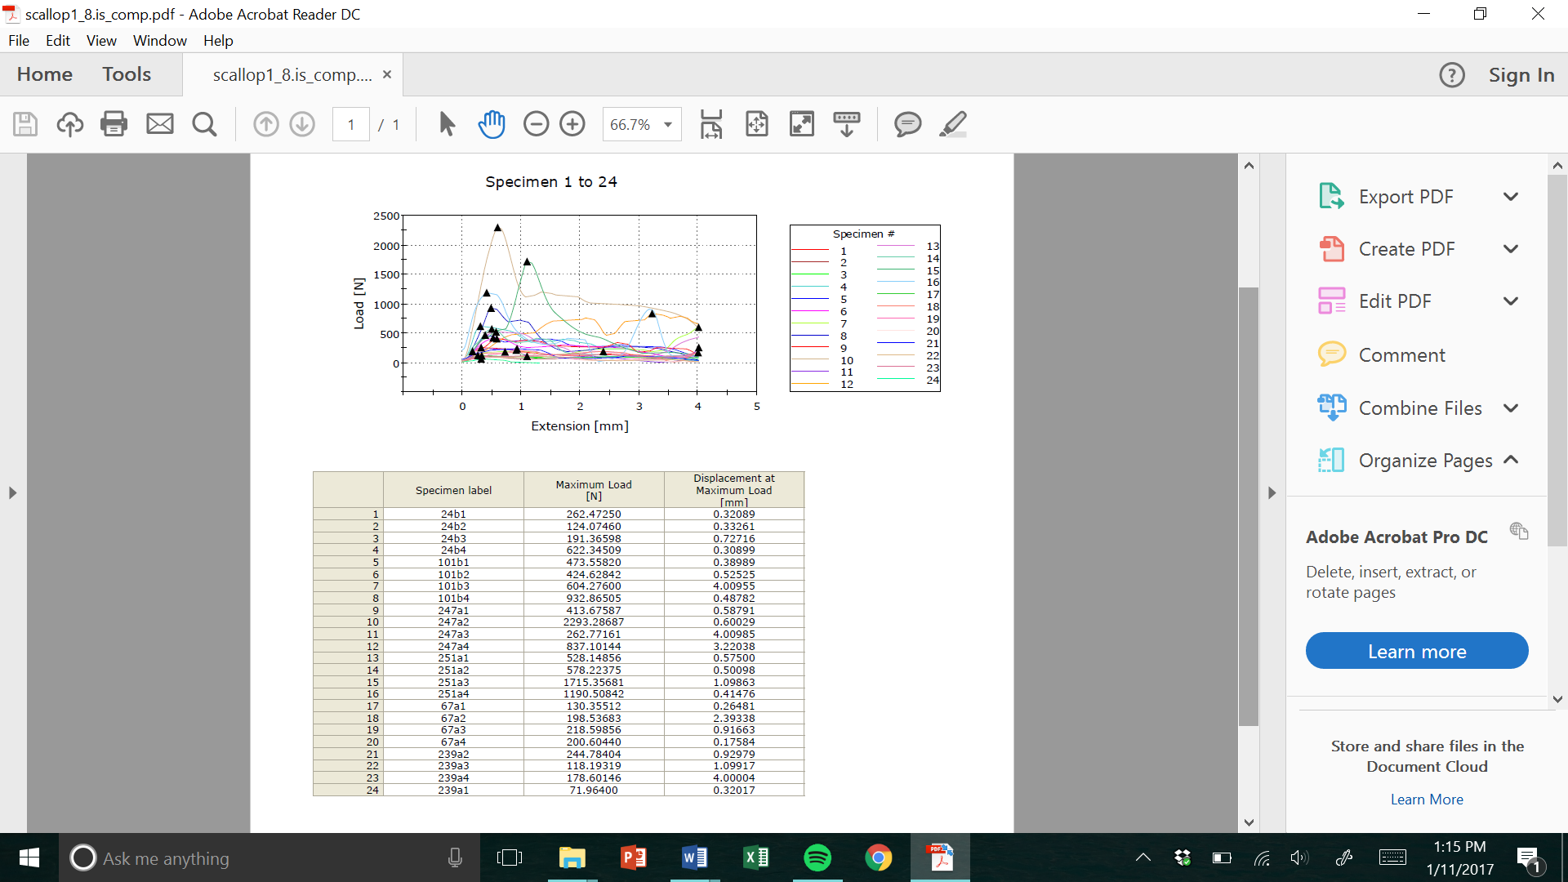

**Post method:**

Shells were measured for thickness at each crushing point using a digital outside caliper gauge with a 0.01 mm accuracy. The compression measurements were normalized by the shell thickness and area of the pin, and the four values from each shell were averaged to give us the overall compressive failure of shell in compressional pressure (N/mm2) and force density unit (N/mm3). The force density can be calculated by the formula below, where F is the maximum load (N), t is the thickness of the shell (mm), and r is the radius of the metal pin head (mm).

A Two-way ANOVA was made to compare correlations between live and empty shells, and between stressors. Linear regressions were created to assess the relationship between shell thickness and force needed to puncture a hole in the shell (Wilke and Bishop 2013).

Wilkie, Emma M., and Melanie J. Bishop. "Differences in shell strength of native and non-native oysters do not extend to size classes that are susceptible to a generalist predator." *Marine and Freshwater Research* 63.12 (2013): 1201-1205.